Intelligent Molecule Design to Explore Potential Solvents for carbonyl sulfur （COS） Capture Based on Reaction Kinetics

Yuxiang Chen¹, Chuanlei Liu¹, Yue Lou¹, Yang Zhao¹, Cheng Qian¹, Hao Jiang¹, Kongguo Wu¹, Hui Sun^{1,2,}*, Di Wu^{3,4,5,6,}*, Fahai Cao¹
1. School of Chemical Engineering, East China University of Science and Technology, Shanghai 200237, China
2. International Joint Research Center of Green Energy Chemical Engineering, East China University of Science and Technology, Shanghai 200237, China
3. Alexandra Navrotsky Institute for Experimental Thermodynamics, Washington State University, Pullman, Washington 99163, United States
4. The Gene and Linda Voiland School of Chemical Engineering and Bioengineering, Washington State University, Pullman, Washington 99163, United States
5. Materials Science and Engineering, Washington State University, Pullman, Washington 99163, United States
6. Department of Chemistry, Washington State University, Pullman, Washington 99163, United States
…
*Corresponding author: sunhui@ecust.edu.cn, d.wu@wsu.edu

Introduction
The advantages of low operating costs and renewable use of solvent compounds drive their widespread use for the removal of toxic and environmentally harmful sulfide species from natural gas or various petroleum resources. During the past several decades, many solvents have been successfully used for industrial absorption processes of sulfide capture. However, the removal of carbonyl sulfur (COS) is still a serious task, which requires more perfect solvents. ^{[1,2]} The number of potential candidate compounds is huge, with small molecules ranging from 10²³ to 10⁶⁰. Currently, most solvents are developed based on experiments, which is considered to need to be more efficient.
The rapid development of machine learning methods influences the development of solvents in the chemical industry. Traditional machine learning methods require large amounts of data as support. However, it is very time consuming to obtain reaction kinetic data using quantum chemical calculations. Therefore, it is necessary to develop an intelligent molecular design method that makes it possible to start from no data and makes each designed molecule provide the maximum amount of information by specifying the next meaningful molecule. In this paper, we propose an intelligent molecule design approach to encode and decode discrete molecules into multidimensional continuous variables by variational autoencoder (VAE) ^{[3]}, based on Bayesian optimization (BO) ^{[4]} to define the next molecule with a potentially high reaction rate. We use a very small number of strategic calculations to progressively generate molecules that have larger reaction rates with COS.
Methodology
VAE was train with 250,000 molecules to convert discrete representations of molecules to and from a multidimensional continuous representation. Then, starting with a single molecule, we use BO to find the next molecule with potential reaction possibilities. After finding next molecule, we used Gaussian 09 to calculate the transition state at B3LYP/6-31G*, the reaction barrier at M06-2X/def2-TZVP. Then the reaction rate constant of this molecule was obtained based on the transition state theory. Repeat the above steps until the calculated reaction rate constant change is no longer significant.
Results and Discussion
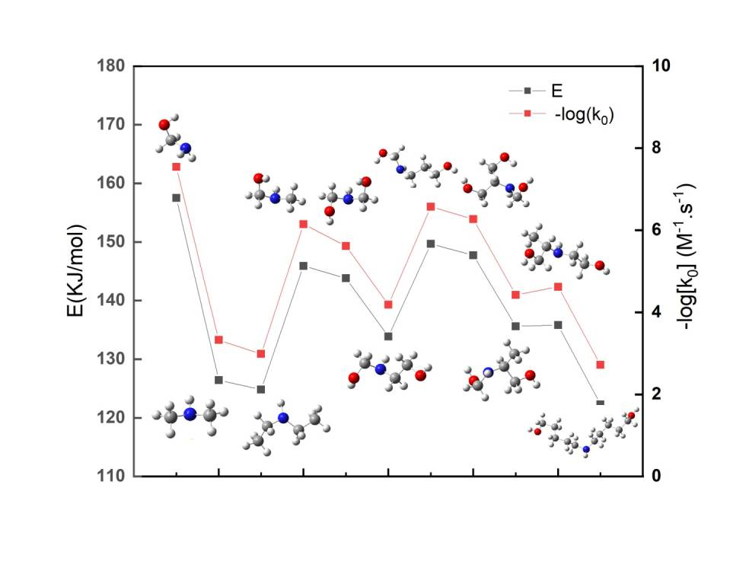
Figure 1. Generation process starting from methanolamine
Molecular numbers from 1 to 11 undergo molecular growth processing. Starting from methanolamine to the most complex molecule of No. 11, it has experienced the process of increasing hydrocarbon radical, hydroxyl group and hydrocarbon chain length. From the change of reaction activation energy and pre-exponential factor with molecular growth process, we can get the following conclusions. From molecule 1 to molecule 3, when methylamine increases hydrocarbon group, the increase of electron donor group makes the amine base stronger, and the reaction proceeds faster. From molecule 4 to molecule 6, at first, with the addition of hydroxyl, the electron donor of hydrocarbon group is weakened, and the alkalinity is relatively weakened. With the growth of alkyl chain with hydroxyl group, the alkalinity increases gradually, which speeds up the reaction speed. From molecule 7 to molecule 11, at first, the hydrocarbon group structure next to the secondary amine becomes complex, making the steric hindrance effect weaken the reaction speed. With the growth of hydrocarbon chain, the electron donor effect increases, and the steric hindrance effect weakens, making the reaction faster.
Conclusion
In this study, we developed a novel targeted Search method for active selection of the next optimal molecule based on molecular sequential coding. With this approach, we can start with a certain base molecule and generate more potentially effective molecules. We also found that the Molecular generation process showed a certain regularity, which can help us understand the COS reaction rate effect from the perspective of conformational changes.
References
[1] Rivera-Tinoco R , Bouallou C . Reaction kinetics of carbonyl sulfide (COS) with diethanolamine in methanolic solutions[J]. Industrial & Engineering Chemistry Research, 2013, 47(19).
[2] Study of hydrogen sulfide absorption with diethanolamine in methanolic aqueous solutions[J]. Chemical Engineering Transactions, 2016, 52.
[3] Gómez-Bombarelli, R.; Wei, J. N.; Duvenaud, D.; Hernández-Lobato, J. M.; Sánchez-Lengeling, B.; Sheberla, D.; Aguilera-Iparraguirre, J.; Hirzel, T. D.; Adams, R. P.; Aspuru-Guzik, A., Automatic Chemical Design Using a Data-Driven Continuous Representation of Molecules. ACS Central Science 2018, 4 (2), 268-276.
[4] Bajaj, I.; Arora, A.; Hasan, M. M. F., Black-Box Optimization: Methods and Applications. In Black Box Optimization, Machine Learning, and No-Free Lunch Theorems, Pardalos, P. M.; Rasskazova, V.; Vrahatis, M. N., Eds. Springer International Publishing: Cham, 2021; pp 35-65.
Keywords
molecule design; COS capture; reaction kinetics

